**Assignment 19.3**

**1. Write a MapReduce program that takes the output of Task 5 (refer session 7, assignment 1) as input, and produce output which is sorted on the total units sold. You may use a single reducer for the sorting. Use Sequence File formats as an output of Task 5 and as input for this task.**

**Sequence File Input:**

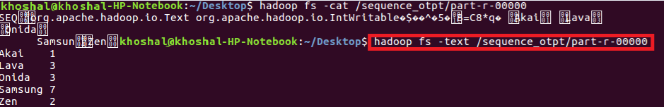

As we want to order the company based on total units sold I will define a composite key which contains company and sold count and sort based on units sold.

**Driver:**

Set composite key class as Outputkey class and nullwritable as value.

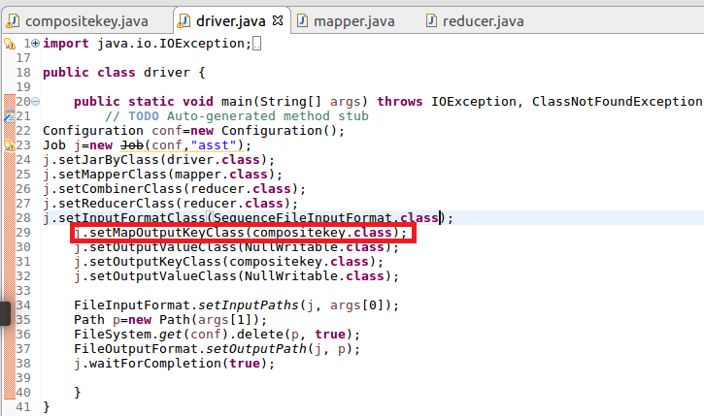

**Mapper:**

**Read the sequence file input and send composite key (consisting of company and count) as Key and nullwritable as value.**

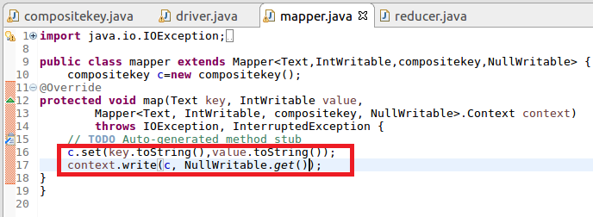

**compositeKey**

**Step1:** Override compare to method and sort the key based on total units sold in descending order.

**Step2:** Override ToString Method and display the output in the way we want to display.

**Step3:** read field and write fields is for serialization and deserialization.

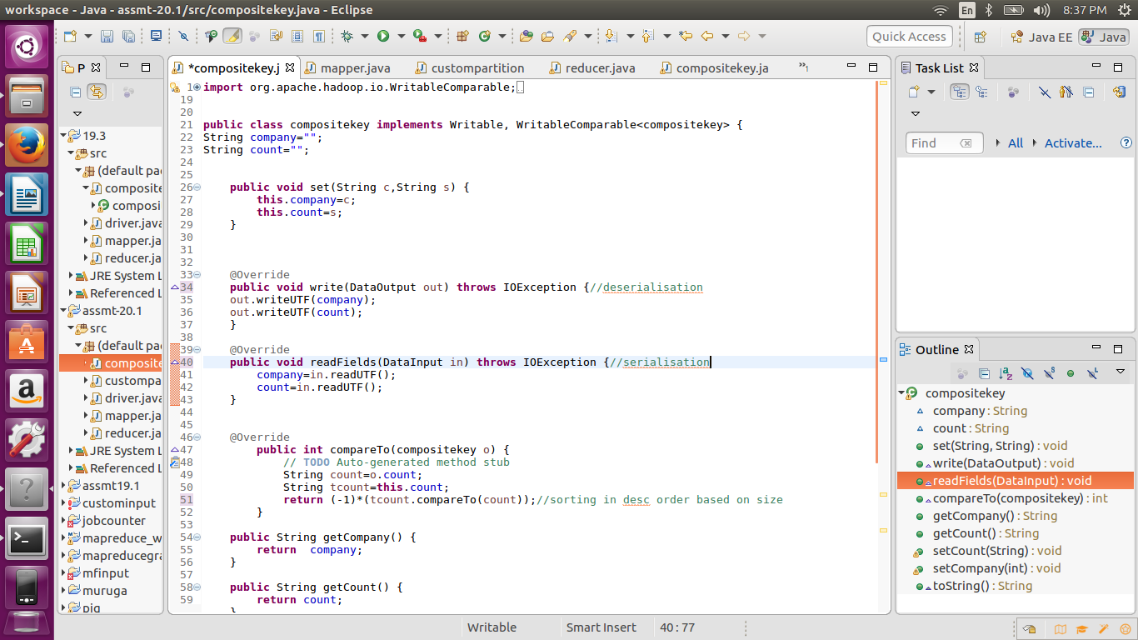

**Reducer:**

Writing the composite key and value.

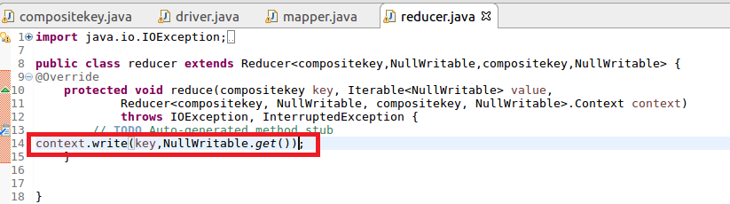

**Running Jar:**

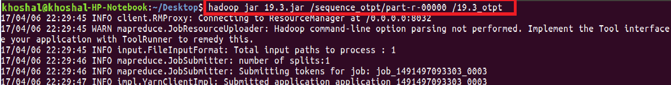

**Output:**

**Inference:** company sorted based on total Units sold.

